**Profile**

### Create A Profile

|  |  |
| --- | --- |
| Team Id | AD47707C5D4D5109D5E480002BDB30D50 |
| Project Tittle | Build an Event Management System using salesforce |

### From Setup enter Profiles in the Quick Find box, and select Profiles.  2. From the list of profiles, find Standard User.  3. Click Clone.

### Screenshot (14).png

### Screenshot (16).png

4. For Profile Name, enter Event vendors profile.   
5. Click **Save**.

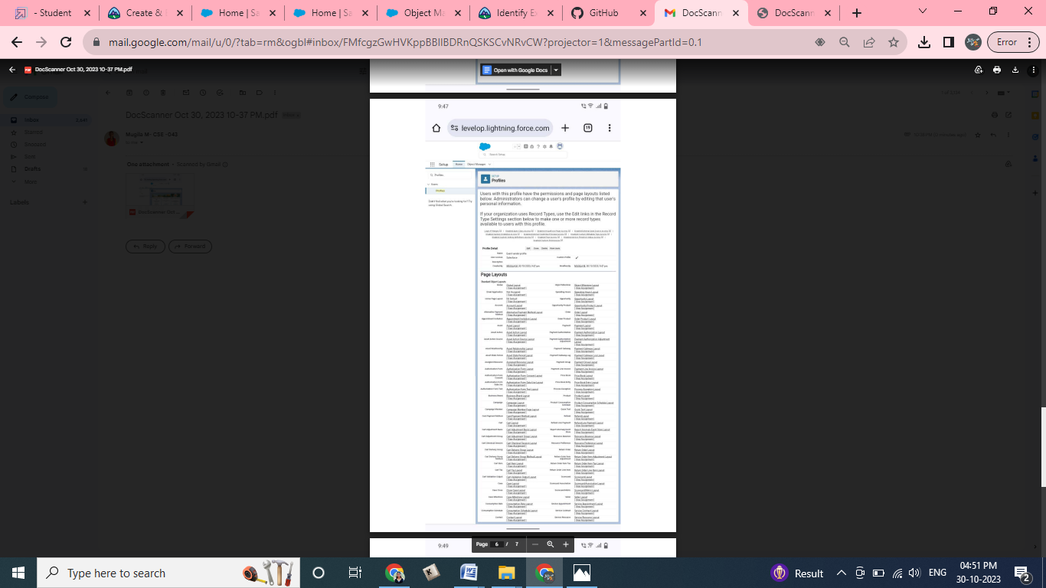

6. While still on the Event profile page, then click **Edit**.

7. Scroll down to Custom Object Permissions and Give view all access permissions to the Attendees, speakers and vendors.   
